

Industrial Automation MCTR701

Project

Milestone: …..

|  |  |  |  |  |  |  |
| --- | --- | --- | --- | --- | --- | --- |
| Supervised by | | Prof. Dr. Atef Afifi | | | | |
| Submitted To | | industrial.automationmctr701@gmail.com | | | | |
| Submitted By | | Kareem Haitham Mohamed el-sabbagh | | | | |
| ID | 37-2947 | | Tutorial | 27 | Group | 2 |

|  |
| --- |
|  |
|  |

Milling 2d

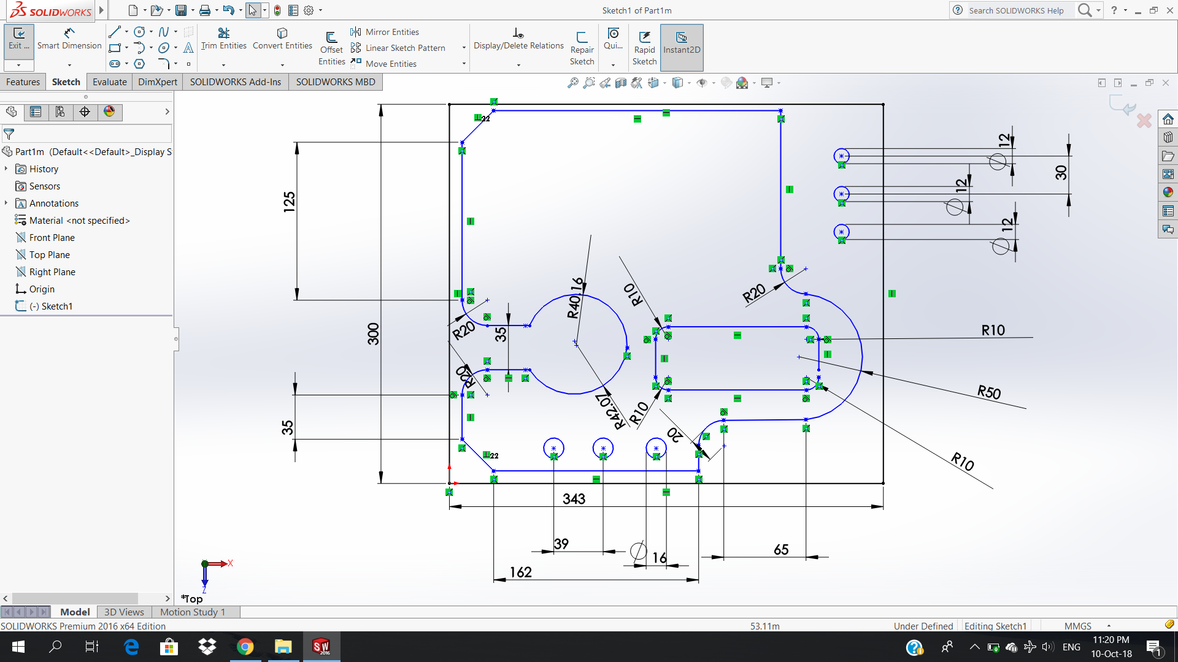

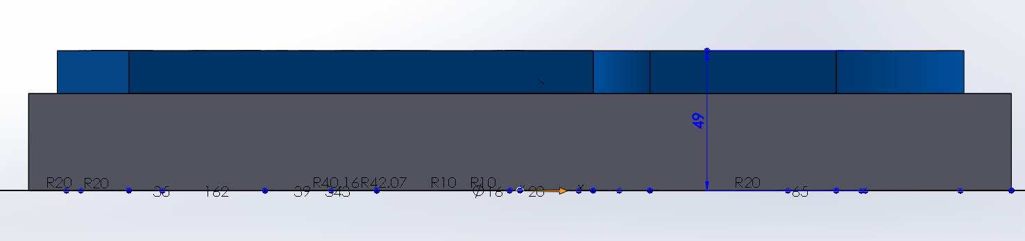

Milling 3d

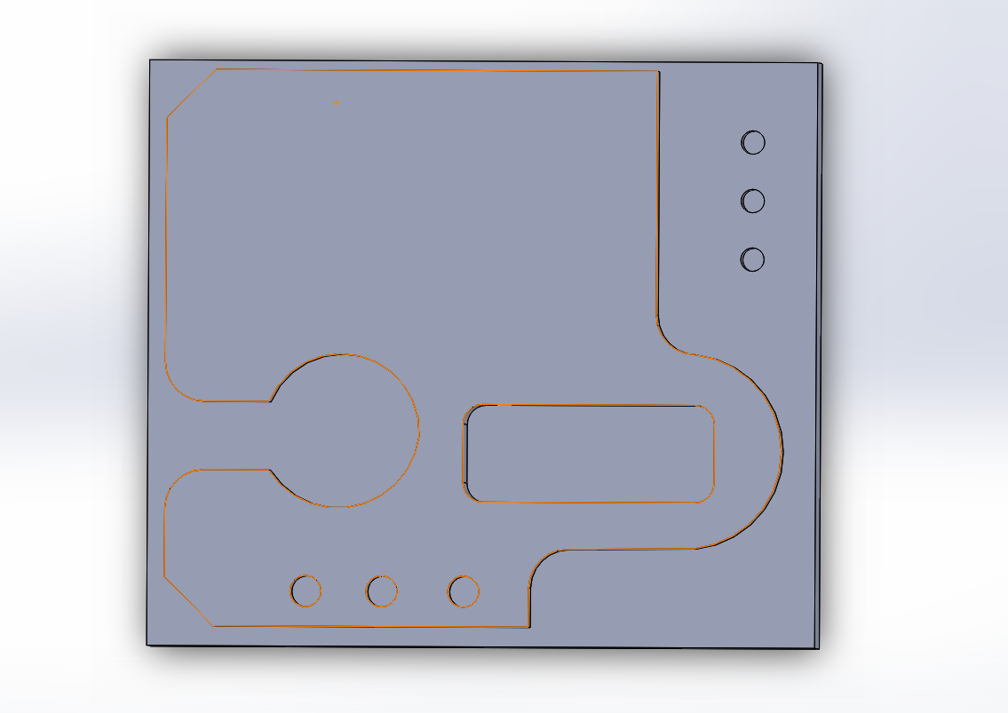

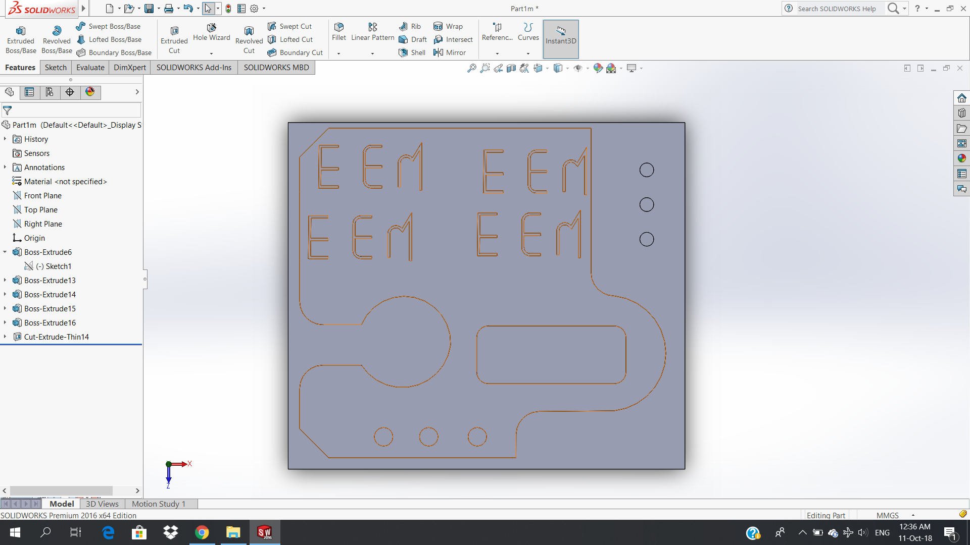

Turning

